SIT302 Project

Programmers Guide

Online Book Store



GROUP 6

YOUSEF NAIF A ALHARBI

NOHA JAMALI A SALEM

FAISAL ABDULLAH M BIN GHIMLAS

AHMED AL SHAMISI

ABDULLAH ALDOKHIIL

AVIRAJ KAMBOJ

JALAB JALBANI

# Table of Contents

Table of Contents 2

1.0 Introduction 3

1.1 Document Purpose 3

2.0 Navigation 3

3.0 System architecture 3

4.0 Technologies used 4

5.0 Database 5

5.1 Entity-Relationship diagram 5

6.0 Coding style descriptions 5

6.1 Coding style 5

7.0 Folder and file descriptions (System folders only) 6

8.0 Bibliography 7

# 1.0 Introduction

## 1.1 Document Purpose

The purpose of this document is to provide a comprehensive programmer’s guide. This document explains the details that a programmer will need in order to maintain and enhance the Online Book Store system.

# 2.0 Navigation

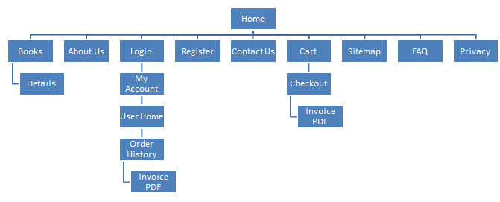

# 3.0 System architecture

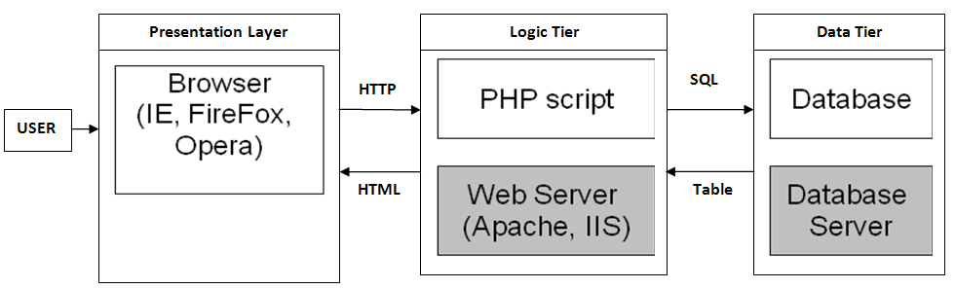

Figure : Three tier website architecture (Tarhini 2011)

The architecture of the system is standard 3-tier architecture for web systems. The following table explains the components of the system that belong in each of the layers of the 3-tier architecture:

|  |  |
| --- | --- |
| **Architecture Layer** | **System Component** |
| User | The end-user of the system. There are two types of end-users in the system:   1. The shoppers who will access the front end of the system 2. The administrators (the business owners) who will manage product catalogues, order history and will be responsible for shipping orders |
| Browser | The web browser will be the client side software used to access the system (both the front-end and the administration section). |
| PHP Script | The PHP scripts will be the native PHP code and the PDO libraries to render the administration section and the front-end to the users. |
| Database | The database will be a MySQL database that will store all data for the system. |

# 4.0 Technologies used

| **Technology Name** | **Description** |
| --- | --- |
| MySQL 5.0+ | The MySQL Technology has been used for the database.  Uses MySQL for all data storage including configuration data, user data, product data and order data.  The MySQL 5.0+ version is used.  The testing has occurred for at least MySQL 5.0 and MySQL 5.5. |
| PHP 4.0+ | The PHP Server Side programming language is used for rendering server side information and developing the shopping cart.  Objective oriented PHP should have been used.  The view, model and data have been clearly separated. |
| PDO PHP Database Library 3.0+ | The PDO Database library has been used to protect against the database sq. injection attacks. |

# 5.0 Database

## 5.1 Entity-Relationship diagram

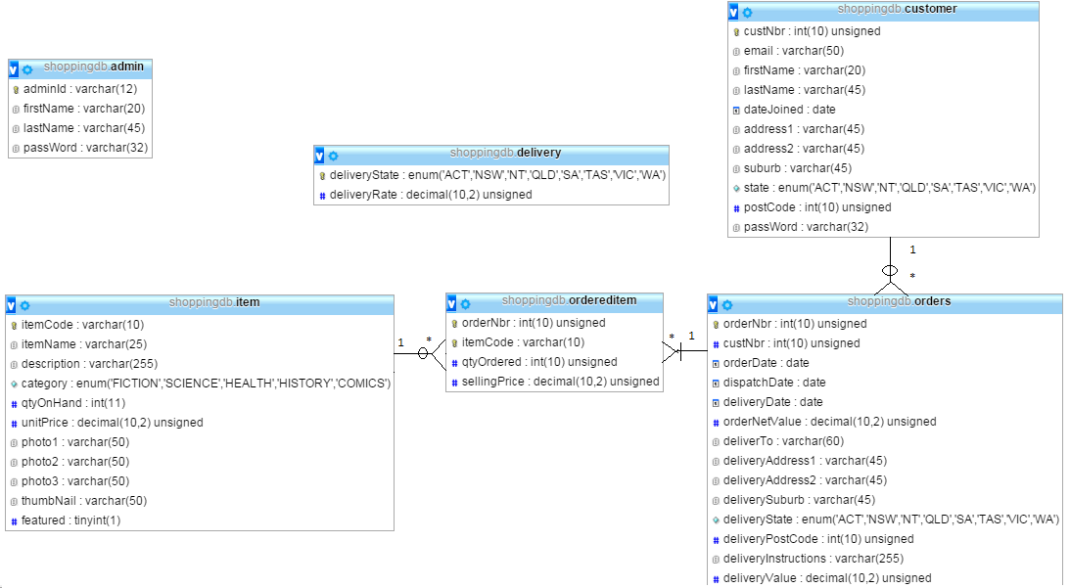

# 6.0 Coding style descriptions

## 6.1 Coding style

The MVC model for code development has been used for the purpose of this project. The following example explains the general coding structure used in the website development.

There is a folder for each area of the website. For example,

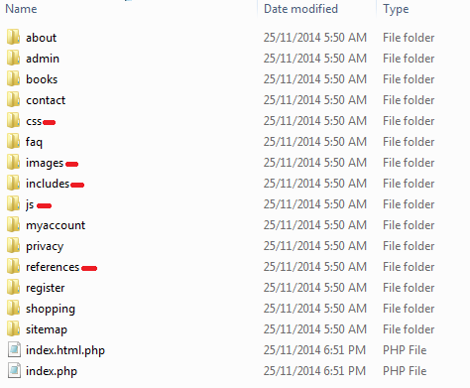

In this screenshot, the folders that have been marked with red are system folders. Other folders all correspond to a page or set of pages on the website. Now, if we look inside the “Contact” folder that contains the code for contact page.

There are two files for each folder:

|  |  |
| --- | --- |
| **The .php page** | The .php page is responsible for all of the database interaction. The page loads all of the data from the database (and updates the database). The page sets up arrays or variables which can be accessed by the view to render the output to the user. |
| **The .html.php page** | This is the HTML template that reads the arrays or variables of data that are setup by the .php page and displays them to the user. |

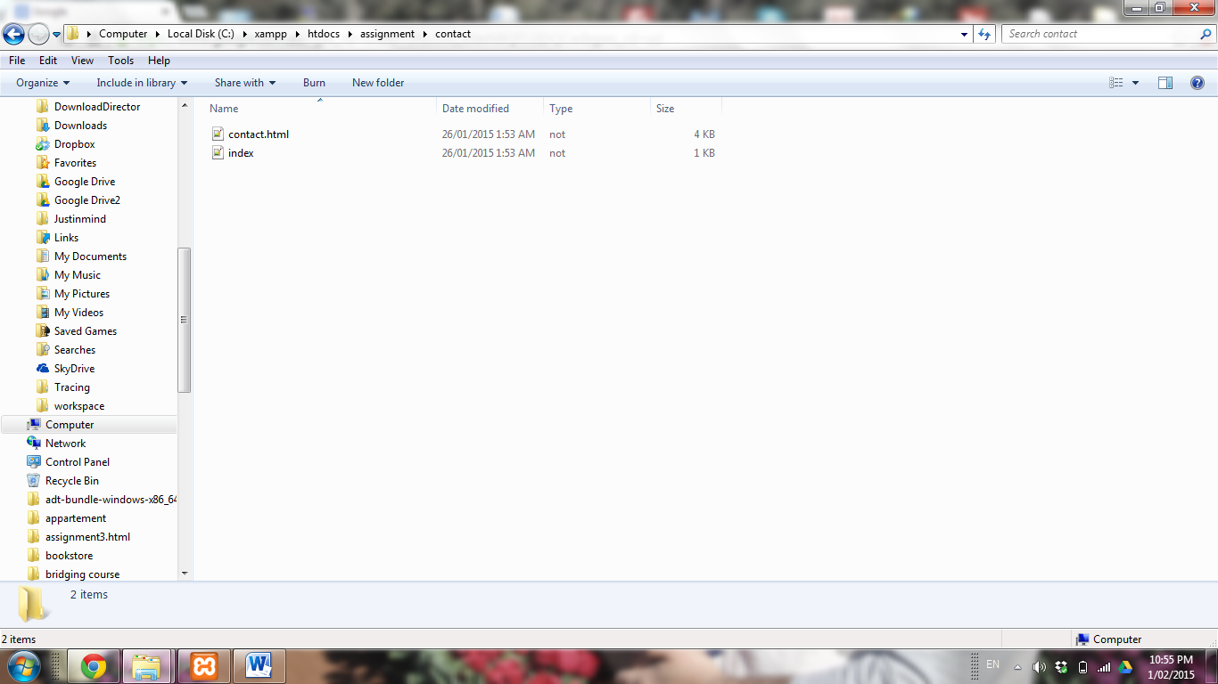

# 7.0 Folder and file descriptions (System folders only)

Table

|  |  |  |
| --- | --- | --- |
| **Folder Name** | **File Name** | **Description** |
| CSS | Lightbox.css | The CSS for displaying the images and making them larger when the user clicks on them. |
|  | Style.css | The styling information for rest of the website. |
| Images | *Image files* | The images displayed throughout the website. |
| Includes | Cart.inc.php | Setup variables for cart by loading details from the database. |
|  | Cartdisplay.inc.php | The html file that displays the cart. |
|  | Categories.inc.php | Setup variables for categories by loading the details from the database. |
|  | Db.inc.php | Setup the database setting parameters. |
|  | Error.html.php | A generic error page that will be displayed if there is an error. |
|  | Footer.inc.php | The file that displays the generic footer on each page. |
|  | Formvalidator.inc.php | The generic validation library that is used in each of the forms. |
|  | Header.inc.php | The generic header displayed on top of each file. |
|  | Helpers.inc.php | The miscellaneous functions for string manipulation throughout the website. |
|  | Magicquotes.inc.php | The magic quotes that sanitize the input for database interaction. |
|  | Simpleimage.php | The php code that loads an image from a given file path. |
| References | Books.txt | References to all the images that have been used |

# 8.0 Bibliography

Ideal Software, Programmer’s Manual Template, accessed on 15 January 2015 at <http://www.idealsoftware.com/vpe_download/ProgrammersManual.pdf>